Monthly Status Report – September 2026
Millbrook Solar & Storage
Liam McAllister · 02 October 2026 · MB-PM-RPT-202609
Area | RAG | Comment
Overall | Green | Consultation #3 on 16 September presented the amendments.
Cost | Green | Development spend EUR 2.61 m of EUR 3.10 m budget (84 %)
Schedule | Green | Planning decision Q1 2027 – on track
Stakeholders | Green | Consultations held: 3 of 3

Summary
Consultation #3 on 16 September presented the amendments. Support rose to 53 %. The Highways Authority confirmed CTMP Rev 2 addresses its concerns in principle.

Key figures
Metric | Value
Capex estimate (P50) | EUR 78.0 m
Open risks | 16
Consultation responses to date | 472
Development spend to date | EUR 2.61 m

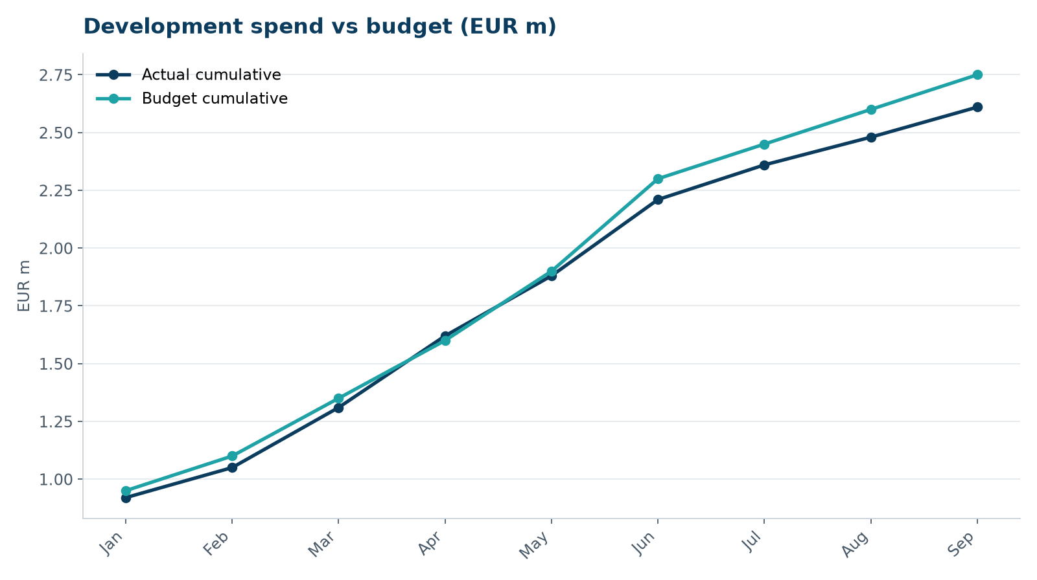
Development spend vs budget

Next month
- Amendment pack to council by 16 October
- Consultation #3 feedback report
- Start EPC negotiation

